Module 4.2 – Supervised Learning: Classification

Topic: Logistic Regression (Customer Churn, Loan Approval, Email Spam Detection)

Lesson Introduction
Mini Agenda:
- Understanding Classification
- Logistic Regression Introduction
- Logistic Regression with MLE
- Model Evaluation Metrics (Confusion Matrix, Precision, Recall, F1, ROC AUC)
- Bias-Variance Trade-off
- Overfitting & Underfitting
- Practical Exercise with Dataset
- Business Scenario
- Practice Session
- Case Study
- Assignment, Quiz & Recap

Real-World Hook
Question:
Have you ever wondered how Netflix predicts whether you’ll like a movie, or how banks decide if your loan will be approved?
Problem:
Businesses need to predict categories — like YES/NO, Fraud/Not Fraud, Churn/Stay.

Introduce Topic as a Solution
Solution: Logistic Regression is one of the most widely used classification algorithms that predicts probabilities and helps make binary decisions based on data.

Theory Explanation

1. What is Logistic Regression?
A statistical method to model the probability of a binary outcome using the sigmoid function.
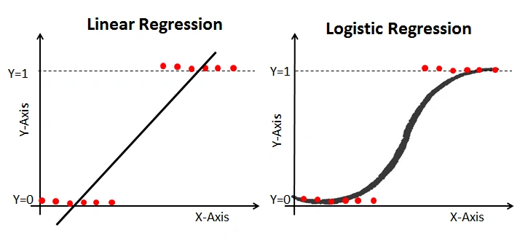
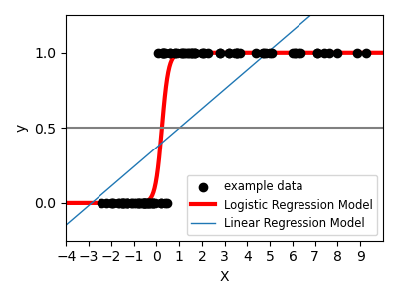

2. Why use it?
- Converts continuous inputs into probabilities (0–1).
- Interpretable and quick to implement.
- Works well when the relationship between dependent and independent variables is linear in log-odds space.
https://www.analyticsvidhya.com/blog/2022/02/decoding-logistic-regression-using-mle/

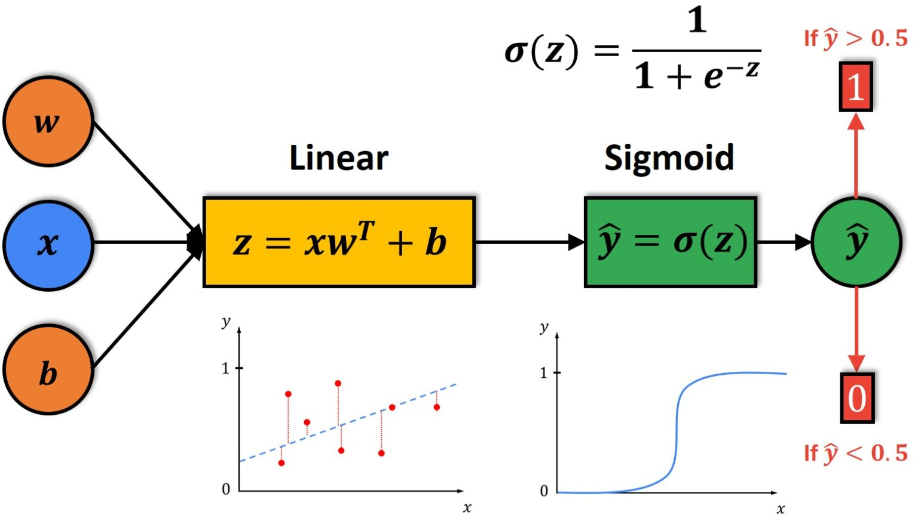
https://datahacker.rs/004-machine-learning-logistic-regression-model/

3. When to use it?
- Customer churn prediction.
- Loan approval.
- Email spam classification.
- Medical diagnosis (disease/no disease).

4. How does it work?
- Takes input features XX.
- Calculates linear combination: z=β0+β1x1+β2x2+...z = β_0 + β_1x_1 + β_2x_2 + ...
- Passes zz through sigmoid function:
p=11+e−zp = \frac{1}{1 + e^{-z}}
- If p>0.5p > 0.5 → Class 1, else Class 0.

5. Syntax
from sklearn.linear_model import LogisticRegression

model = LogisticRegression()
model.fit(X_train, y_train)
y_pred = model.predict(X_test)

6. Example
Dataset: Customer churn prediction
Features: MonthlyCharges, Tenure
Target: Churn (0 = Stay, 1 = Leave)

7. Advantages
- Easy to implement & interpret.
- Outputs probabilities.
- Requires less computational power.

8. Disadvantages
- Works best for linear decision boundaries.
- Not suitable for highly complex relationships.

9. Limitations
- Struggles with non-linear data.
- Can be unstable with highly correlated features.

10. How to overcome limitations
- Use feature transformation (Polynomial, log).
- Apply regularization (L1/L2).
- Use non-linear models (Tree-based).
11. Cost functions/loss function in logistic regression
Log loss

For Logistic Regression we can't use the same loss function as for Linear Regression because the Logistic Function (Sigmoid Function) will cause the output to be non-convex, which will cause many local optima.

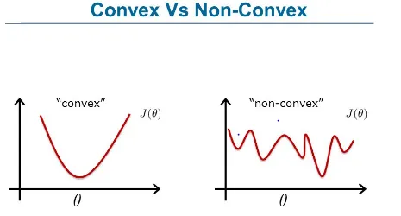

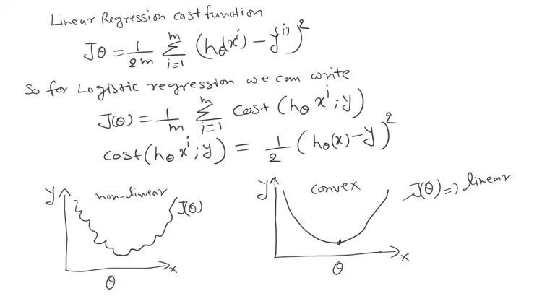
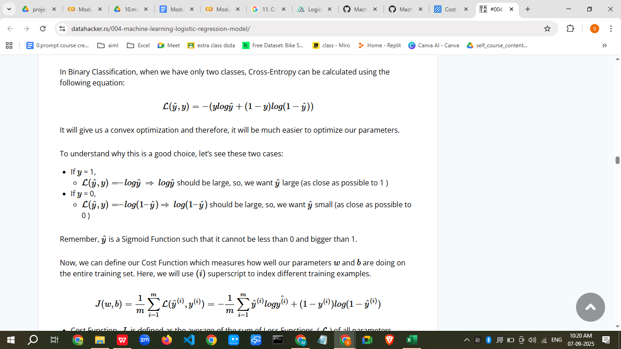

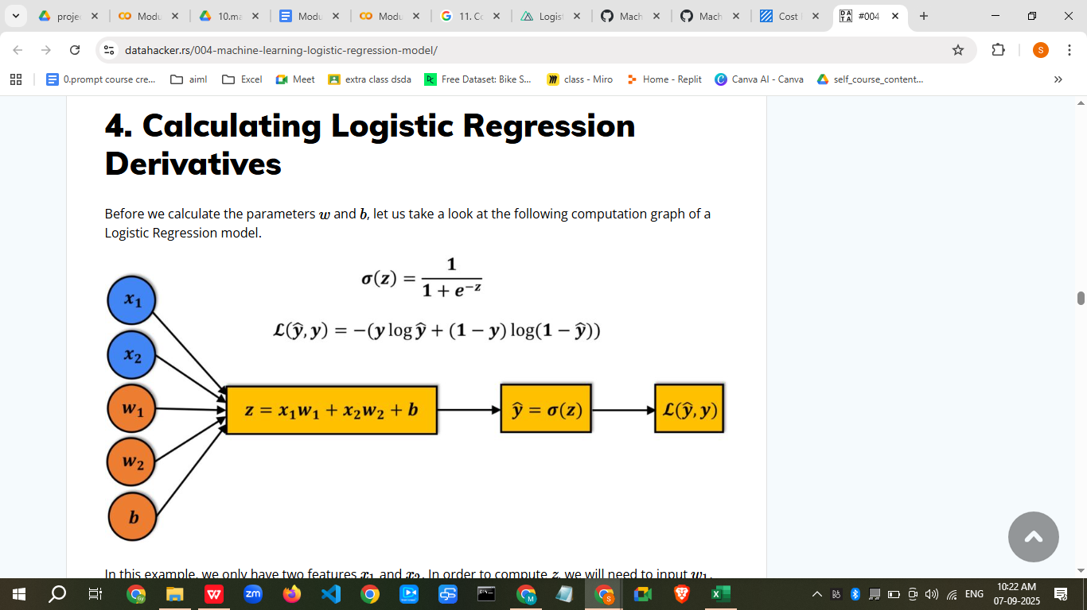

https://ml-explained.com/blog/logistic-regression-explained
nucleusbox.com/cost-function-in-logistic-regression/

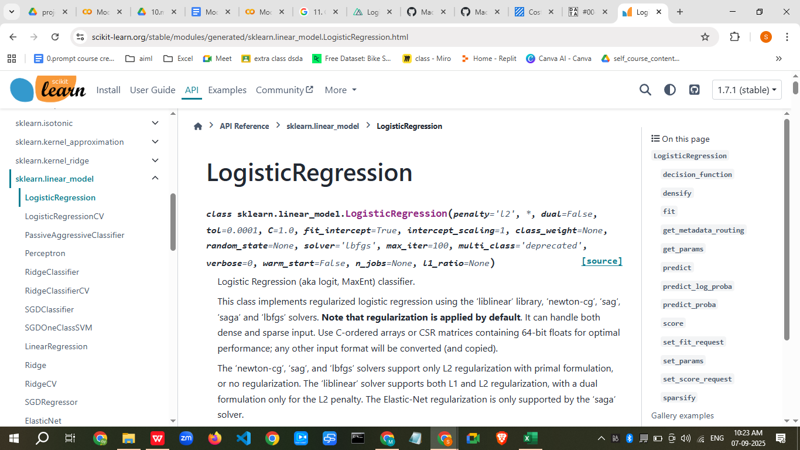

Model evaluation

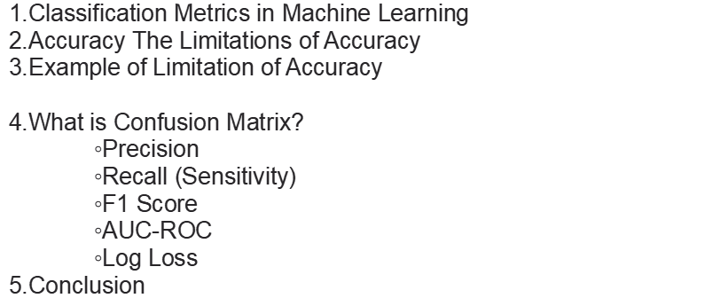
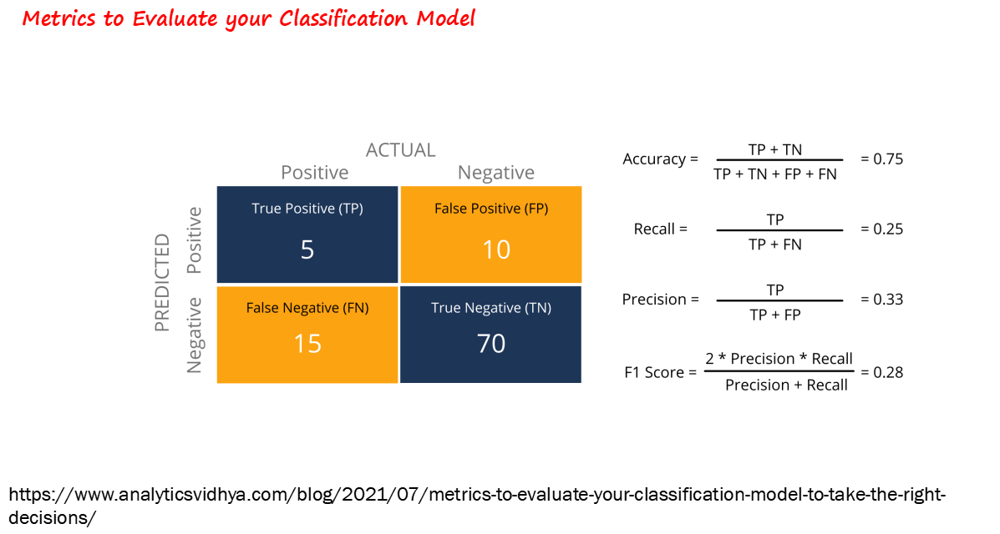
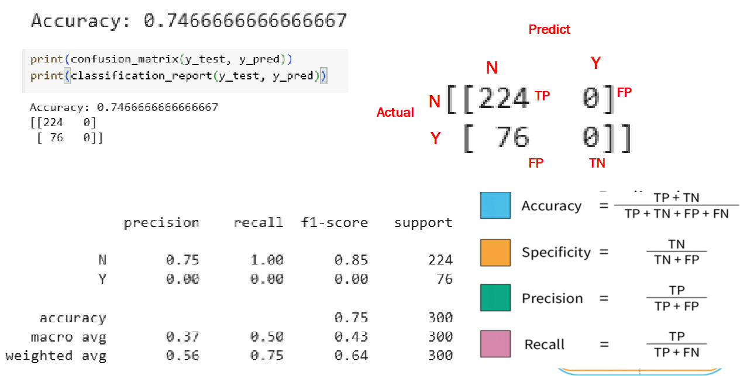
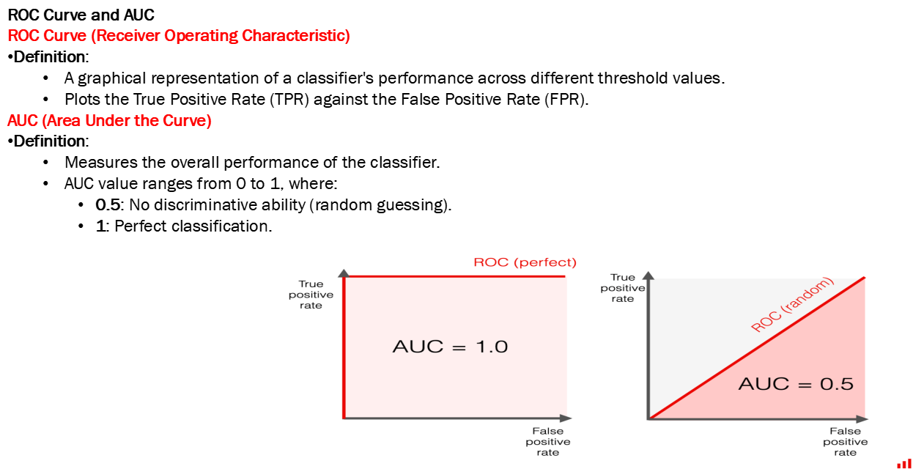
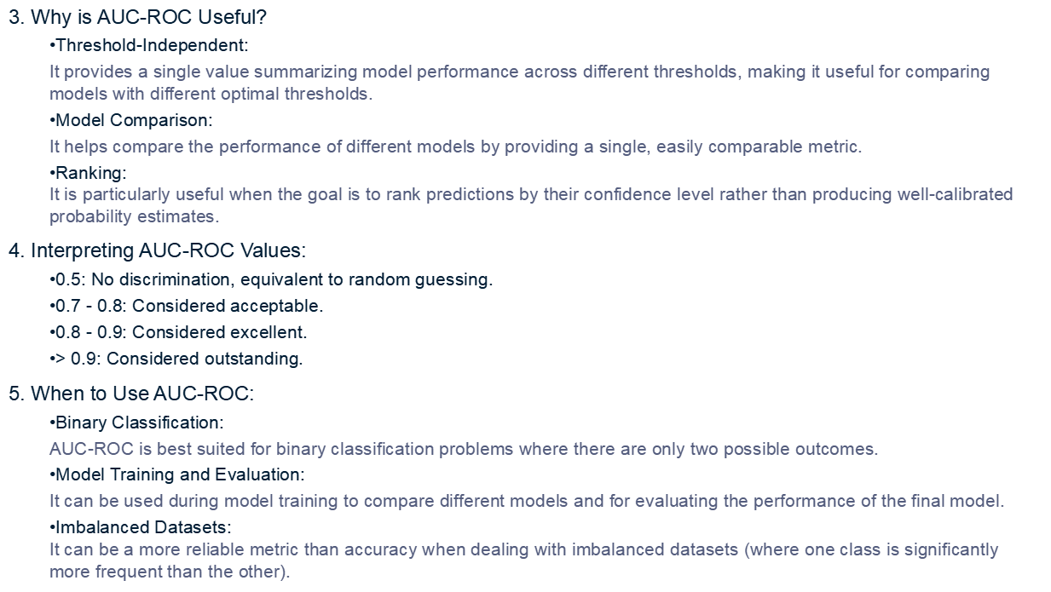

Practical Example – Dataset (50 Points)
import pandas as pd
import numpy as np
from sklearn.model_selection import train_test_split
from sklearn.linear_model import LogisticRegression
from sklearn.metrics import classification_report, confusion_matrix

# Creating Dataset
np.random.seed(42)
data = pd.DataFrame({
'MonthlyCharges': np.random.randint(20, 120, 50),
'Tenure': np.random.randint(1, 60, 50),
'Churn': np.random.choice([0, 1], size=50)
})

# Train-Test Split
X = data[['MonthlyCharges', 'Tenure']]
y = data['Churn']
X_train, X_test, y_train, y_test = train_test_split(X, y, test_size=0.3, random_state=42)

# Model
model = LogisticRegression()
model.fit(X_train, y_train)
y_pred = model.predict(X_test)

# Evaluation
print(confusion_matrix(y_test, y_pred))
print(classification_report(y_test, y_pred))

Business Scenario
Company: Telecom Provider
Goal: Reduce customer churn by identifying high-risk customers using logistic regression and offering retention discounts.

Practice Session (5 Questions)
- Predict loan approval using Income & Credit Score.
- Predict if a student will pass based on study hours.
- Predict if a transaction is fraud based on transaction amount.
- Predict if an email is spam using word frequency.
- Calculate model accuracy and ROC AUC for a given dataset.

Case Study
Project: Email Spam Detection
- Dataset: Email word frequency, presence of suspicious keywords.
- Model: Logistic Regression
- Outcome: Automatically classify emails into Spam (1) and Not Spam (0).

Assignment
- Build a logistic regression model on Titanic dataset to predict survival.
- Calculate Accuracy, Precision, Recall, F1, ROC AUC.

Quiz
- What function does Logistic Regression use to map predictions between 0 and 1?
- Name two limitations of logistic regression.
- How can overfitting be reduced in logistic regression?

Recap
Today we learned:
- What Logistic Regression is.
- How to implement it in Python.
- Key evaluation metrics.
- Business use cases.
- Practical coding example.

Resource Links
- Scikit-learn Logistic Regression Documentation
- ML Mastery – Logistic Regression

If you want, I can extend this into a Streamlit UI where students can upload their dataset and run logistic regression with visual metrics for hands-on learning.
Do you want me to make that Streamlit app?

Streamlit app for Module 4.2: Supervised Learning – Classification covering:
- Logistic Regression (Customer Churn, Loan Approval, Spam Detection)
- Logistic Regression MLE
- Performance metrics (Confusion Matrix, Precision, Recall, F1 Score, ROC-AUC)
- Bias-Variance
- Overfitting & Underfitting
I’ll make it interactive so students can:
- Upload their own dataset (CSV)
- Select target column
- Train a logistic regression model
- View predictions and performance metrics
- See visualizations (Confusion Matrix heatmap, ROC Curve, etc.)
Here’s the code:
import streamlit as st
import pandas as pd
import numpy as np
from sklearn.model_selection import train_test_split
from sklearn.linear_model import LogisticRegression
from sklearn.metrics import confusion_matrix, precision_score, recall_score, f1_score, roc_auc_score, roc_curve
import matplotlib.pyplot as plt
import seaborn as sns

st.set_page_config(page_title="Logistic Regression Classification", layout="wide")

st.title("📊 Logistic Regression Classification - Student Interactive App")
st.markdown("""
**Learn by Doing:**
Upload your dataset, select the target column, train a Logistic Regression model, and see how performance metrics work.
""")

# Upload dataset
uploaded_file = st.file_uploader("📂 Upload your CSV dataset", type=["csv"])
if uploaded_file:
df = pd.read_csv(uploaded_file)
st.subheader("📄 Dataset Preview")
st.write(df.head())

# Select target column
target_col = st.selectbox("🎯 Select Target Column", df.columns)

# Prepare data
X = df.drop(columns=[target_col])
y = df[target_col]

# Handle categorical data automatically
X = pd.get_dummies(X, drop_first=True)

# Split data
test_size = st.slider("Test Set Size (%)", 10, 50, 20)
X_train, X_test, y_train, y_test = train_test_split(X, y, test_size=test_size/100, random_state=42)

# Train model
model = LogisticRegression(max_iter=1000)
model.fit(X_train, y_train)

# Predictions
y_pred = model.predict(X_test)
y_prob = model.predict_proba(X_test)[:,1]

st.subheader("📊 Model Performance Metrics")
st.write(f"**Precision:** {precision_score(y_test, y_pred):.2f}")
st.write(f"**Recall:** {recall_score(y_test, y_pred):.2f}")
st.write(f"**F1 Score:** {f1_score(y_test, y_pred):.2f}")
st.write(f"**ROC-AUC:** {roc_auc_score(y_test, y_prob):.2f}")

# Confusion Matrix
cm = confusion_matrix(y_test, y_pred)
st.subheader("🔍 Confusion Matrix")
fig, ax = plt.subplots()
sns.heatmap(cm, annot=True, fmt="d", cmap="Blues", xticklabels=["No", "Yes"], yticklabels=["No", "Yes"])
plt.xlabel("Predicted")
plt.ylabel("Actual")
st.pyplot(fig)

# ROC Curve
st.subheader("📈 ROC Curve")
fpr, tpr, _ = roc_curve(y_test, y_prob)
fig2, ax2 = plt.subplots()
ax2.plot(fpr, tpr, label=f"AUC = {roc_auc_score(y_test, y_prob):.2f}")
ax2.plot([0, 1], [0, 1], "k--")
ax2.set_xlabel("False Positive Rate")
ax2.set_ylabel("True Positive Rate")
ax2.legend()
st.pyplot(fig2)

# Bias-Variance Discussion
st.subheader("📚 Bias-Variance Trade-off")
st.markdown("""
- **Bias**: Error from overly simplistic models (e.g., underfitting).
- **Variance**: Error from overly complex models (e.g., overfitting).
- Goal: Find the balance where both bias and variance are low.
""")

else:
st.info("👆 Upload a CSV file to start.")

Features:
✅ Students can upload any dataset
✅ Auto-handles categorical variables
✅ Interactive model training with test size slider
✅ Shows precision, recall, F1 score, ROC-AUC
✅ Displays confusion matrix heatmap and ROC curve
✅ Includes bias-variance concept explanation

If you want, I can also add:
- Preloaded datasets (Customer Churn, Loan Approval, Spam Detection)
- MLE explanation & math formulas inside the app
- Overfitting/Underfitting detection graph
Do you want me to extend this app with these extra features so students get both theory + hands-on?
Alright ✅
I’ll create a Streamlit Logistic Regression Classification App that allows students to:
- Upload CSV
- Select target column
- Train a Logistic Regression model
- Show Confusion Matrix, Precision, Recall, F1-score, ROC AUC
- Display Bias-Variance & Overfitting/Underfitting notes for learning purposes
Here’s the code:
# logistic_regression_app.py

import streamlit as st
import pandas as pd
import numpy as np
from sklearn.model_selection import train_test_split
from sklearn.linear_model import LogisticRegression
from sklearn.metrics import (
confusion_matrix, classification_report, roc_curve, auc
)
import matplotlib.pyplot as plt
import seaborn as sns

# Streamlit App Title
st.title("📊 Logistic Regression Classification App")
st.write("Upload a dataset and perform Logistic Regression with evaluation metrics.")

# File Upload
uploaded_file = st.file_uploader("Upload your CSV file", type=["csv"])

if uploaded_file:
df = pd.read_csv(uploaded_file)
st.write("### Dataset Preview", df.head())

# Target column selection
target_col = st.selectbox("Select the target column (classification label):", df.columns)

# Feature columns selection
features = st.multiselect("Select feature columns:", [col for col in df.columns if col != target_col])

if features and target_col:
X = df[features]
y = df[target_col]

# Handle categorical variables
X = pd.get_dummies(X, drop_first=True)

# Train-test split
X_train, X_test, y_train, y_test = train_test_split(
X, y, test_size=0.2, random_state=42
)

# Logistic Regression Model
model = LogisticRegression(max_iter=1000)
model.fit(X_train, y_train)
y_pred = model.predict(X_test)
y_prob = model.predict_proba(X_test)[:, 1]

# Confusion Matrix
cm = confusion_matrix(y_test, y_pred)
st.subheader("Confusion Matrix")
fig, ax = plt.subplots()
sns.heatmap(cm, annot=True, fmt="d", cmap="Blues", ax=ax)
ax.set_xlabel("Predicted")
ax.set_ylabel("Actual")
st.pyplot(fig)

# Classification Report
st.subheader("Classification Report")
st.text(classification_report(y_test, y_pred))

# ROC Curve
st.subheader("ROC Curve & AUC")
fpr, tpr, _ = roc_curve(y_test, y_prob)
roc_auc = auc(fpr, tpr)
fig, ax = plt.subplots()
ax.plot(fpr, tpr, label=f"ROC Curve (AUC = {roc_auc:.2f})")
ax.plot([0, 1], [0, 1], 'r--')
ax.set_xlabel("False Positive Rate")
ax.set_ylabel("True Positive Rate")
ax.legend()
st.pyplot(fig)

# Learning Notes
st.subheader("📚 Learning Notes")
st.markdown("""
**Bias-Variance Trade-off**
- **High Bias** → Model is too simple (Underfitting).
- **High Variance** → Model is too complex (Overfitting).

**Overfitting**
- Fits training data too well, performs poorly on unseen data.
- Can be reduced using regularization (L1/L2), cross-validation, and simpler models.

**Underfitting**
- Model is too simple to capture the data pattern.
- Can be improved by adding features, using complex models.
""")
else:
st.info("Please upload a CSV file to start.")

📌 How to Run
- Save as logistic_regression_app.py
In terminal:
pip install streamlit pandas numpy scikit-learn matplotlib seaborn
streamlit run logistic_regression_app.py

- Upload your dataset and follow the instructions.

If you want, I can add an in-built example dataset (Customer Churn) so students can try without uploading anything.
Do you want me to add that?

